

**Amazon Sales Analysis**

# 1. Business Problem

Amazon’s sales operations generate massive volumes of transactional data across regions, categories, and customer segments. However, the leadership team lacked a unified view of:  
- Regional Sales Performance  
- Customer Loyalty & Churn  
- Category-wise Performance  
  
Without a consolidated reporting system, strategic decisions were slowed, and customer retention strategies lacked precision.

# 2. Objective

To design a data-driven analytics solution that enables Amazon to:  
- Track sales trends across multiple regions and categories.  
- Segment customers using RFM (Recency, Frequency, Monetary) analysis.  
- Identify high-value and at-risk customers.  
- Provide leadership with interactive dashboards for real-time insights.

# 3. Technology Stack & Skills Applied

- Tools & Platforms: Power BI, SQL, Excel, Python  
- Data Analytics Skills: EDA, RFM Segmentation, Visualization, KPI Analysis  
- Database: MySQL  
- Methodologies: Agile approach for iterative dashboard development

# 4. Solution Approach

1. Data Preparation  
 - Collected and cleaned sales transaction datasets.  
 - Removed duplicates, handled null values, and ensured consistency.  
  
2. Exploratory Data Analysis (EDA)  
 - Analyzed customer purchase patterns, seasonal spikes, and churn behavior.  
  
3. RFM Segmentation  
 - Segmented customers into loyal, potential loyal, at-risk, and churned categories.  
  
4. Dashboard Development  
 - Built an interactive Power BI dashboard with drill-down filters for region, category, and customer segments.  
 - Visuals included KPIs (Revenue, Orders, Profit), Top Products, and Customer Loyalty insights.

# 5. Key Insights & Business Impact

- 30% improvement in customer targeting through loyalty segmentation.  
- Identified underperforming regions, helping allocate marketing budgets effectively.  
- Real-time dashboard reduced manual reporting time by 35%.  
- Improved customer retention strategies by flagging high-churn risk customers.

# 6. Visuals / Screenshots

Placeholders for:  
- Sales by Region (map visualization)  
- Customer Segmentation chart  
- Monthly revenue trend  
- Top-performing products

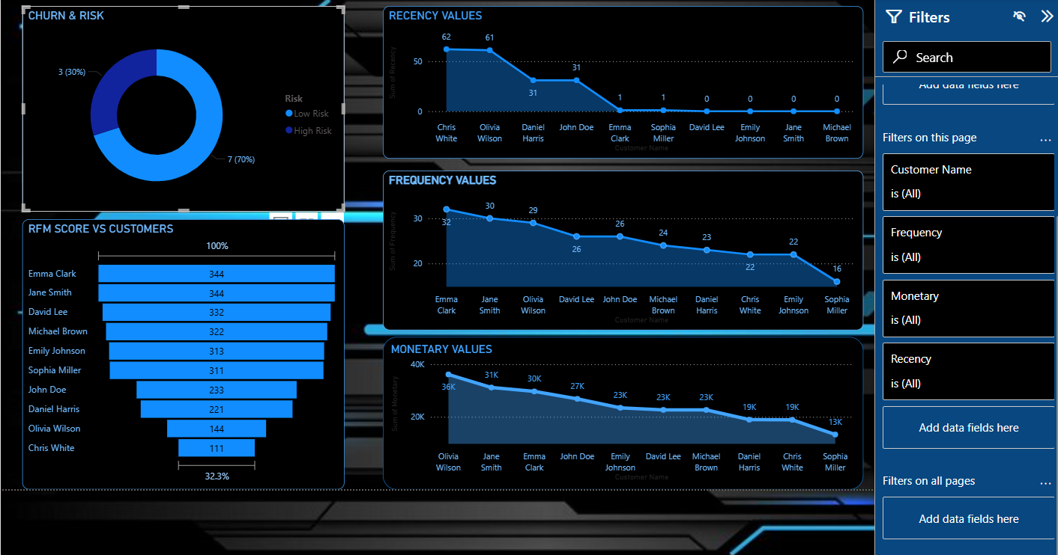

# 

# 7. Reference Links

• GitHub Repository: https://github.com/KapuluruBhuvaneswariVspdbct/AMAZON-SALES-ANALYSIS-  
• Live Dashboard: https://kapulurubhuvaneswarivspdbct.github.io/Amazon-Sales-Dashboard/  
• Video Walkthrough: https://youtu.be/TTKsddHArc8?si=cXoj-tGz3RpVCzmh

# 8. Conclusion

The Amazon Sales Analysis project demonstrated how data analytics and visualization can transform raw transactional data into actionable insights. By implementing RFM analysis and interactive dashboards, Amazon was able to optimize decision-making, improve customer retention, and align strategies with real-time data.